Preserved Lemon Aioli
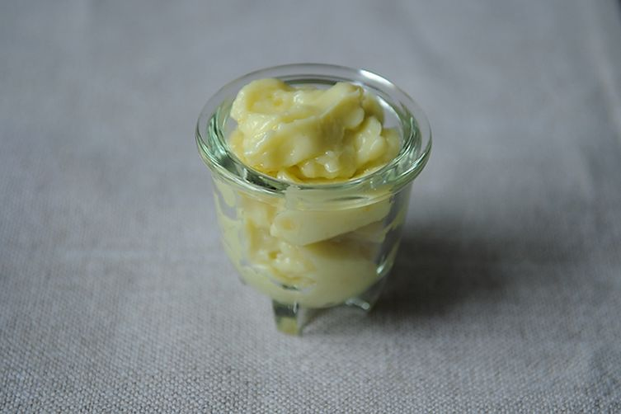
100 g preserved lemon (or to taste)
3 clove garlic
6 egg yolks
Juice of 1 lemon
salt
250 ml sunflower oil
¼ cup mint

- Remove flesh from preserved lemon. Remove any excess salt. Finely chop the skin of the preserved lemon.
- Peel and crush garlic. Cut lemon in half and juice.
- Separate eggs. Place lemon and garlic in the food processor with the egg yolks, lemon juice and salt, to taste.
- Blend until the mixture is smooth. With the motor running, slowly pour the sunflower oil in until the ingredients have emulsified and formed a mayonnaise.
- Wash mint, remove leaves from stems and finely chop.
- Stir chopped mint into aioli.
- Check the seasoning and serve.

