Hummus Pizza with Feta Cheese and Arugula
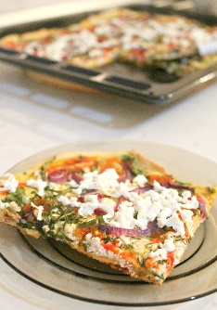
Ingredients
- 2 pizza bases (see separate recipe for pizza dough)
- 400g canned chickpeas drained and rinsed
- juice from 1 lemon
- 1 clove of garlic, crushed
- ½ teaspoon cumin or caraway seeds
- 200 g feta cheese, crumbled
- 100g arugula leaves (rocket)
- 1 ½ red onion, finely chopped
- 1 teaspoon olive oil
- 4 spoons tomato paste
Instructions
- 1. Use a food processor to make a hummus paste out of chickpeas,lemon juice and garlic. Add cumin or caraway seeds
- 2 Season to taste with salt and pepper and add a little water to get a spreadable consistency (if needed).
- 3 Preheat oven at 200 C. Wash rocket leaves and dry on paper towel.
- 4 Spread the hummus on pizza crust. Crumble feta cheese.
- 5 Peel & chop red onion. Sprinkle feta cheese, rocket and onions onto pizza.
- 6 Bake for 15 min approximately or until crust is golden brown.
- 7 Mix tomato paste with 6 tablespoons water.
- 8 Remove pizzas from oven and sprinkle tomato paste over evenly
- 9. Sprinkle some more feta cheese. Bake for 5 more minute. Cut pizza and serve.

